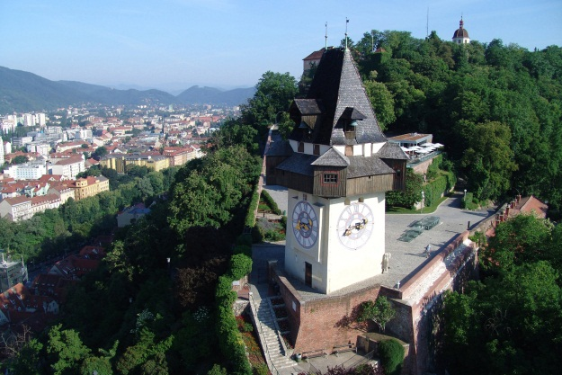
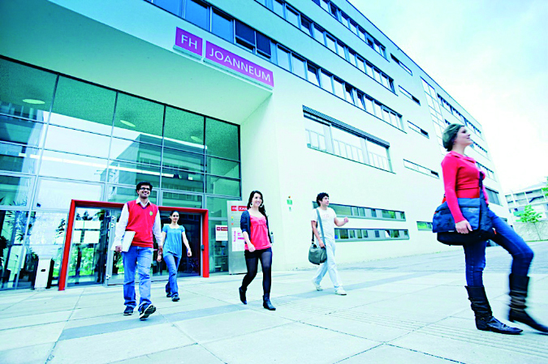
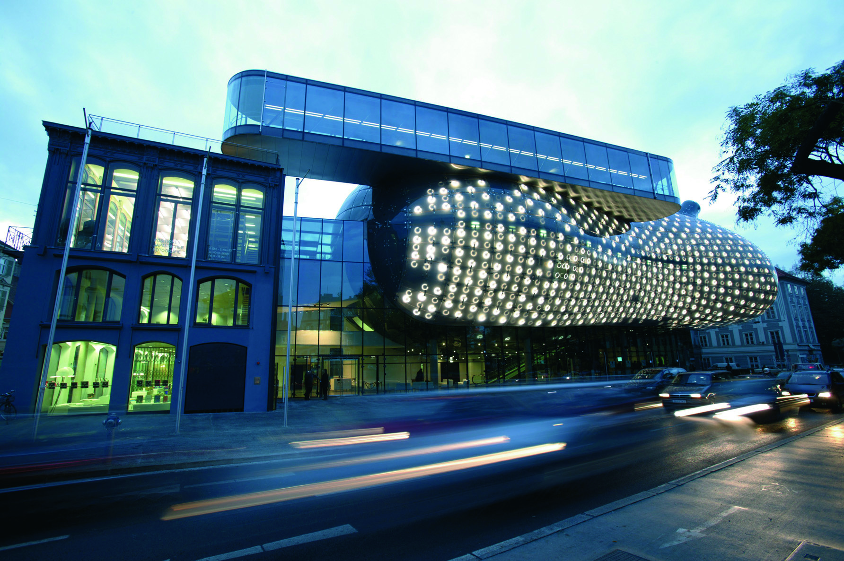
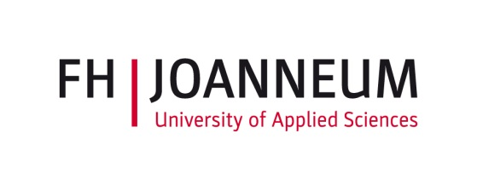
International Staff Week
April 18 – 22, 2016
Preliminary Program

Monday, 18.4.2016
09.00 – 09.15 Arrival, coffee and tea
09.15 – 09.30 Welcome at FH JOANNEUM
09.30 – 10.00 Presentations of participants
10.00 – 11.00 Presentation of FH JOANNEUM
11.00 – 12.30 German Crash Course
12.30 – 13.30 Lunch (cafeteria)
13.30 – 14.00 Campus tour
14.00 – 15.30 Discussion
17.00 – 19.00 Intercultural food sharing (bring something sweet and something sour from your home country)

Tuesday, 19.4.2016
09.00 Bus departure to Kapfenberg
09.45 – 10.30 Welcome and presentation of Campus Kapfenberg
10.30 – 11.15 Workshops
11.15 – 11.30 Break
11.30 – 12.30 Workshops
13.00 Visit of Brewery in Göss
15.30 – 16.30 Bus to Graz

Wednesday, 20.4.2016
09.00 – 11.15 Workshop at your preferred administrative unit at Campus Graz
11.15 – 12.00 Prepare your booth for the Study Abroad Fair (in Audimax, Campus A)
(Please bring information material from your university)
12.00 – 15.00 Study Abroad Fair (in Audimax)
17.00 – 19.00 City Tour of old center of Graz

Thursday, 21.4.2016
09.00 Bus departure to Bad Gleichenberg
10.00 - 10.30 Welcome and presentation of Campus Bad Gleichenberg
10.30 - 11.30 Intercultural Game
11.30 – 11.45 Break
11.45 – 12.30 Workshops
12.30 – 13.30 Lunch
13.30 – 15.15 Excursion to Riegersburg (castle in Eastern Styria)
http://veste-riegersburg.at/
15.15 – 18.00 Excursion to Zotter Chocolate Manufacturer (tasting included!)
http://www.zotter.at/en/homepage.html
19.00 Arrival in Graz

Friday, 22.4.2016
09.00 – 11.00 Workshop at your preferred administrative unit at Campus Graz
11.00 – 12.00 Feedback Session, signing documents, good byes

